Based on the binary phase diagram of Ni-Cu alloy, answer the following questions. Show your work by drawing lines on the diagram. The same diagram is include on the next page for convenience.
1. A 80 wt% Ni–20 wt% Cu alloy is slowly cooled from 1500°C to 1150°C. At what temperature does the first solid phase form?

2. A 80 wt% Ni–20 wt% Cu alloy is slowly cooled from 1500°C to 1190°C. At the temperature that the first solid phase forms, what is the composition of the solid phase?

3. Based on the binary phase diagram of Ni-Cu alloy, if a sample (20% Ni) is slowly cooled from 1500ºC to 1190ºC, what is the mass fraction of the α phase? (Show your calculation work.)

3. Based on the binary phase diagram of Ni-Cu alloy, if a sample (20% Ni) is slowly cooled from 1500ºC to 1100ºC, what is the mass fraction of the α phase? (Show your calculation work.)

Refer to the binary diagram of x-y alloy below, answer the following questions. Please show your work by drawing lines on the diagram.
4. What is the melting temperature of pure x?
(a) 50ºC (b) 1080ºC (c) 1630ºC (d) 825ºC
5. What is the eutectic composition of x-y alloy?
(a) 22% Sn (b) 40% Sn (c) 61.3% Sn (d) 90% Sn
6. What is the eutectic temperature of the alloy?
(a) 50ºC (b) 1080ºC (c) 1630ºC (d) 825ºC
7. A sample composed of 30% x is slowly cooled from 1800ºC, at what temperature does the first solid phase form?
(a) 980ºC (b) 1080ºC (c) 1630ºC (d) 825ºC
8. For the same sample, at what temperature does the liquid solidify (complete solidification)?
(a) 980ºC (b) 1080ºC (c) 1630ºC (d) 825ºC
9. A sample composed of 30% x is slowly cooled from 1800ºC, what is the composition of this last remaining liquid phase?
(a) 23% (b) 40% (c) 95%
10. which is the microstructure of the alloy sample (30% x) at 400 ºC?
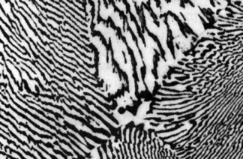

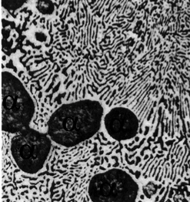
α

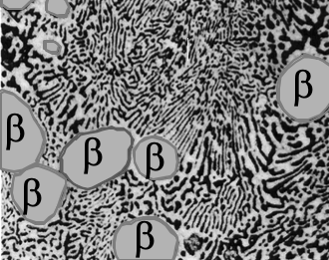
wt. % X
11. What is the mass fraction of phase particles (primary $α$) in the sample at 400 ºC?

12. What is the mass fraction of the eutectic $α$ in the sample at 400 ºC?

13. If there is a total of 20 kg of the metal allow, how many kg of the alloy is eutectic β?
The remaining Problems refer to the Iron-Carbon phase diagram below. (Show your work, please.)
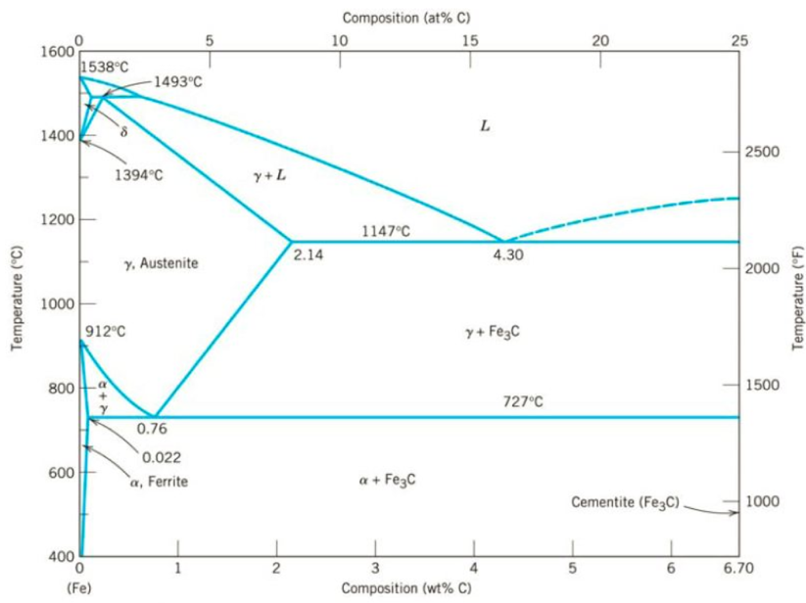
14. On the graph, label the eutectic (A) , peritectic (B), and eutectoid points (C).

15. What is the eutectoid composition? What is the eutectoid temperature?

16. An FE-C alloy at the eutectic composition would be consider which type of material?
a) Steel b) cast iron c) iron carbide (ceramic)

17. For a 99.5 wt% Fe-0.50 wt% C steel at a temperature of 750ºC, which phases are present?

18. As the same alloy cools, which phase is completed converted to pearlite?

For a 99.5 wt% Fe-0.50 wt% C steel at a temperature just below the eutectoid (<727 ºC, say 725ºC)
19. Determine the mass fractions of total ferrite (α) and cementite (Fe₃C) phases.

20. Determine the mass fraction of total pearlite phase.

